November 2021
Newsletter

We have moved…
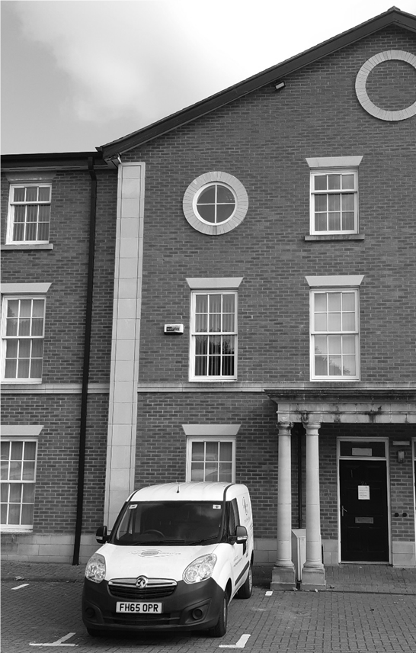
From the beginning of September our Derby Head Office has been in a new home. We are at 2a Wentworth House, Vernon Gate, Derby, DE1 1UR. Our telephone number, email and other social media addresses remain unchanged (see back page for details). The new office provides a more suitable office base and we now have a small meeting room too. Our Chesterfield office is still on St Margaret’s Drive.

Though some Covid restrictions remained in place, over the summer we have been busy getting a number of services safely back up and running. Our VIP Information days have all proved very popular and been very well received. We are busy planning dates for 2022 and will send a calendar out early next year so that you can get dates in your diary.

Our rehabilitation services have continued throughout the pandemic. A lot of the support was offered by telephone and posting out equipment. Lately we have got back to providing more home visits and this newsletter highlights two people that have really benefited from the service.

Rehabilitation can help with practical skills and support, but it also helps to re-build confidence and promote independence.
All of our services are risk assessed and our staff will talk to you about our Covid safety measures before a visit. So, if you need any advice or support do get in touch and we will always try our best to help.

Rehabilitation Services
Living with sight loss doesn’t need to stop you from doing most of the things you want to do, but you may need to learn to do things in a different way.

Case Study 1 – re-learning cooking skills
Andrew is registered as Severely Sight Impaired and as his sight deteriorated he had been eating a lot of takeaway meals. His doctor advised him to eat healthier meals to reduce the likelihood of developing diabetes.

Following rehabilitation training Andrew has re-learnt various skills associated with food preparation (chopping, peeling and grating), hob/oven management, how to measure ingredients, manage cooking times and how to store food safely in the fridge and freezer.

After several sessions of support, Andrew can now safely make a range of nutritious meals from a stir fry to pasta bake. He said:
“I found it difficult to follow healthy recipes through talking books and the TV, as they did not teach me how to do tasks like chopping, measuring and how to use my hob/ oven safely.
For the first time I went to a friend’s barbeque party and took food that I had prepared myself. Everyone enjoyed it and some people asked me for the recipe. I felt very proud of myself.’’

Case Study 2 – getting out and about
Julie is registered as Severely Sight Impaired and her limited level of vision meant that she was dependent on her daughter to take her out and about.

Julie requested support with learning to travel independently around her local area. Her confidence had deteriorated significantly due to being confined to her house over lock-down.

Following cane skill training and help with route planning, Julie is now able to walk to her local GP surgery on her own and no longer has to rely on family to take her to the local shop. She said:

“I never thought that I’d get on with the long cane as I’d tried in the past but didn’t like it, but now I realise how it can support me to venture out on my own.”

Julie is now in the process of learning the route to her daughter’s house so that she can visit her daughter without having to be picked-up.

Children’s services
The Children and Young People’s Group have enjoyed being able to meet face-to-face again. They have really enjoyed seeing their friends again and having fun together.

The group visited Markeaton Park to try out the inclusive cycles, had a great day at Chatsworth Farm and adventure play area where they were able to feed and handle the animals. The final activity of the summer school holiday was a day trip to Whitemoor Lakes, an outdoor pursuit centre. The group tried abseiling, zip wiring and in the afternoon everyone got wet on the lake while they were having fun canoeing.

Over the summer we found out that BBC Children in Need will once again help with funding our activities which really helps with the amount we need to raise.

Derby Theatre Christmas Trip
We have a few tickets left for the matinee performance of ‘Treasure Island’ including a pre-production Touch Tour on Wednesday 8th December at 1.15 pm. If you would like a ticket, please contact Heather Davidson on 01332 292262/01332 287003 heather.davidson@sightsupportderbyshire.org.uk

Thank you from Fundraising
We have received some fantastic support over the past year. If you’ve made a donation, become a regular giver or raised money by any other means, thank you.

Our Winter Raffle is going ahead, with some great prizes. Please find some tickets enclosed to sell on our behalf, if you can. You can also buy tickets online from our website. Scan the QR code above or type this into your browser to go to the page: www.sightsupportderbyshire.org.uk/donate/enter-winter-raffle-2022

Please return all ticket stubs, cheques and unsold tickets by Tuesday 25th January 2022, to our Derby office – address below. The raffle will be drawn on Wednesday 26th January.

Contact Us:
Derby Head Office  2a Wentworth House  Vernon Gate  Derby  DE1 1UR | Chesterfield Office  1b St Margaret’s Drive Chesterfield  Derbyshire  S40 4SY

Telephone: 01332 292262
We are there from 9am to 5pm, Monday to Thursday.
Email: enquiries@sightsupportderbyshire.org.uk
Website: www.sightsupportderbyshire.org.uk
Search @SightSupDerbys to find us on Facebook and Twitter.

